Resting 12-lead ECG:

* standard test for measuring the heart’s electrical function
* 12 electrodes are placed on the chest, arms, and legs at the same time

Holter monitor:

* Type of ecg for monitoring electrical activity continuously for 24 hours or longer
* Electrodes are taped on the skin
* Go about your daily routine
* Recommended if doctor suspects palpitations or inadequate blood flow to heart

Signal-averaged ECG:

* More detailed
* Multiple electrical activities of the heart gathered over 20 minutes
* Checks for abnormal heartbeats
* Checks if patient is at high risk of arrythmia, which can cause cardiac arrest
* Procedure is similar to resting ecg with more sophisticated equipment

What does ECG measure?:

* Rate and rhythm of heartbeats
* Size and positions of the heart chambers
* Presence of any damage to the heart’s muscle cells
* Presence of impaired blood flow to the heart
* Effects of cardiac drugs
* The function of implanted pacemakers
* Pattern of abnormal electric activity

When is ECG performed?:

* As a routine physical examination or evaluation
* As a cardiac exercise test
* As an evaluation of symptoms of:
  + Chest pain
  + Shortness of breath
  + Fainting
  + Palpitations
  + Dizziness

What conditions can be diagnosed?:

* Abnormally fast or irregular heart rhythms
* Abnormally slow heart rhythms
* An enlarged heart
* Poor blood supply to the heart
* An abnormal position of the heart
* An inflammation of the heart
* Previous heart attack
* Damage to the heart
* Cardiac arrest during emergency room or intensive care monitoring
* Disturbances of the heart’s conducting system

THE PART YOU NEED TO KNOW:

Conduction system of the heart:

|  |  |  |
| --- | --- | --- |
| Right Atrium:   * SA Node: sinoatrial node, natural pacemaker of the heart (this is where conduction starts), goes to AV node   + Sends an impulse between 60-100bpm * Deoxygenated blood comes in, passed to right ventricle |  | Left Atrium   * Oxygenated blood comes in (from lungs), passed to left ventricle |
| Border:   * AV Node: atrioventricular node, gatekeeper of the heart (decides which impulse to let through), goes through the Bundle of HIS   + If SA node generates a weak impulse, AV node will not let that impulse go through and conduct it’s own impulse instead     - Sends an impulse between 40-60bpm | Bundle of HIS:   * Conduction travels through this and splits in two, one going the left and the other to the right * Carries impulse from the AV node   + If signal came from the SA Node, can carry between 60-100bpm   + If signal came from the AV Node, can carry between 40-60bpm |  |
| Right Ventricle:   * Deoxygenated blood comes in, passed to pulmonary artery (goes to lungs to oxygenate) | Left and right bundle branches:   * Each branch extends to opposite sides of the Purkinje fibers * Purkinje fibers: exist in the lower edges of the heart on both sides, carry electrical signals * If both av and sa node fail. The Purkinje fibers generate their own impulse that can make a heart beat between 20-40bpm | Left Ventricle   * Oxygenated blood comes in, passed to aorta (goes to the rest of the body) |

Agenda:

1. Research on the chart

3 parts of an ECG in a heartbeat:

1. P wave (represents atrial depolarization, both atria are contracting)
2. QRS complex (R) (represents ventricular depolarization, both ventricles are contracting)
   1. Atrial repolarization is masked by the QRS complex (R) but can be found within it
3. T wave (represents ventricular repolarization, both ventricles are relaxing)

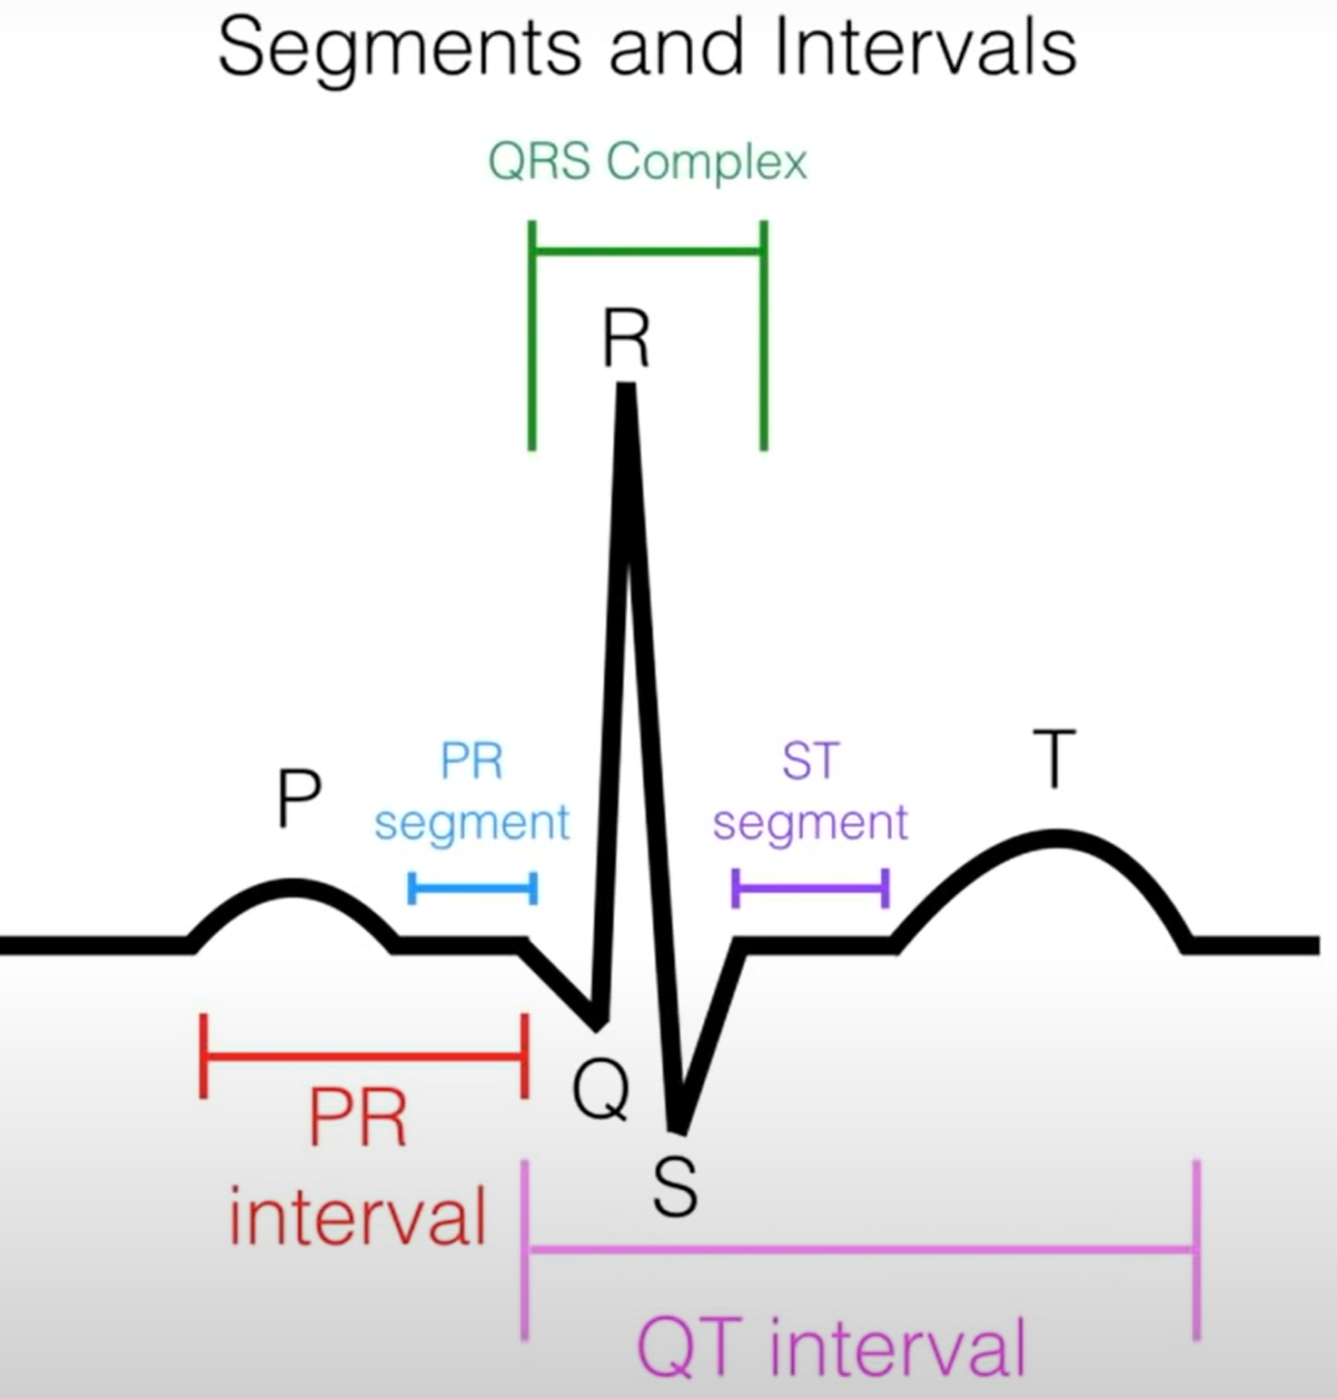

ECG Chart:

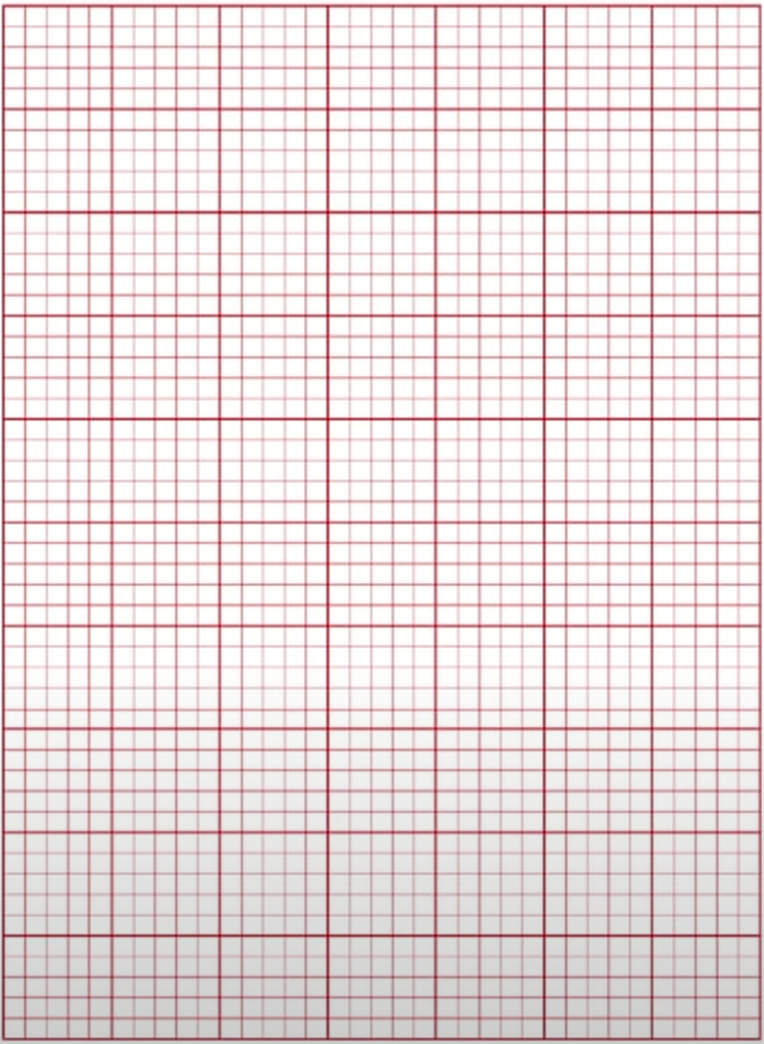

1 small box = 0.04s,

So 1 big box = 0.20s

6 step EKG interpretation:

1. Identify and examine the P wave
   1. The P wave must be:
      1. Present
      2. Upright
   2. If absent or inverted:
      1. Could indicate dysrhythmia such as junctional rhythm
2. Measure the PR Interval
   1. The distance between the start of the P wave and the start of the QRS complex (R)
      1. Count number of small boxes in between
      2. Multiply by 0.04 (time of each small box)
      3. Normal range is between 0.12-0.2s
         1. Anything more than 0.2s could indicate dysrhythmia such as a heart block
3. Measure the QRS complex (R)
   1. The distance between the start and end of the R
      1. Count number of small boxes in between
      2. Multiply by 0.04 (time of each small box)
      3. Normal range is between 0.06-0.12s
         1. Anything more than 0.12s could indicate dysrhythmia such as PVC
4. Identify the Rhythm
   1. Rhythm can be either
      1. Regular – consistent distance between peaks of QRS complex (R)
      2. Irregular – inconsistent distance between peaks of QRS complex (R)
   2. Count boxes between peaks of QRS complex (R) and keep checking on every new peak for rhythm
5. Determine the heart rate
   1. The 6-second method:
      1. Determine the strip length, using lines on top of graph strip
         1. 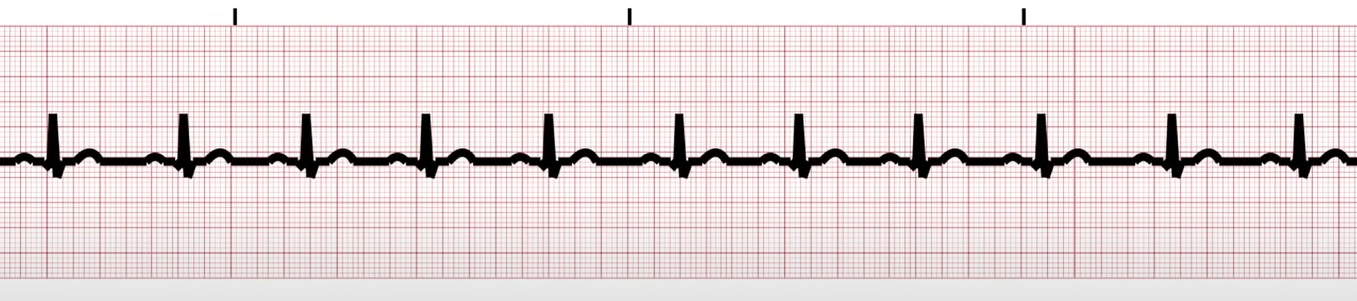
         2. From example strip above: if you find three lines above a strip, the time between the 1st and 3rd line is 6 seconds
      2. Count the number of QRS complex (R) peaks between the 1st and 3rd line
      3. Multiply by 10 to get the total number of heartbeats in a minute
      4. This method works best for irregular heartbeats
      5. THIS METHOD ONLY WORKS FOR 6-SECOND STRIPS
   2. The big-box method:
      1. 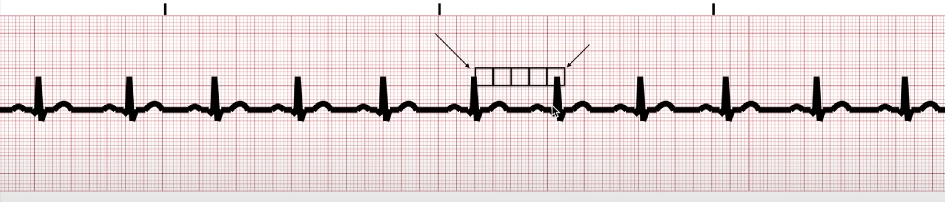
      2. Count the number of big boxes between two QRS complex (R) peaks
      3. Perform the operation ‘300 / (big boxes between two peaks)’
      4. THIS METHOD WORKS BEST FOR REGULAR RHYTHMS ONLY
      5. THEIS METHOD CAN BE USED IF YOU DON’T HAVE A 6 SECOND STRIP IN FRONT OF YOU
6. Interpret Strip
   1. Interpret as needed. Perform any operations or call any functions based on strip observation